Comparative Analysis: Previous Models vs Present Models:
Aspect | Previous / Existing Models | Present Models in Our Project
Machine Learning Models | Logistic Regression, Decision Tree, Random Forest and other traditional ML models | Logistic Regression, Random Forest and XGBoost
Data Balancing | Class weighting or basic resampling in many approaches | SMOTE applied to the training data
Feature Processing | Encoding and standard preprocessing | One-hot encoding + preprocessing + SMOTE
Prediction | Employee attrition prediction | Employee attrition prediction
Model Comparison | Often focused on one or a few models | Three models compared using five evaluation metrics
Explainability | Limited or not integrated | SHAP + LIME
Prediction Output | Usually model prediction | Prediction + attrition probability + explanation
User Interface | Often no interactive application | Flask backend + web frontend
Explainability Output | Limited feature interpretation | Individual and global feature explanations
Performance Comparison of Previous Models:
Study / Approach | Model | Accuracy | Precision | Recall | F1-Score | ROC-AUC
Previous Study – IBM HR dataset | Logistic Regression | 79.93% | 41.67% | 63.83% | 50.42% | —
Previous Study – IBM HR dataset | Random Forest | 83.67% | 48.65% | 38.30% | 42.86% | —
Previous Study – IBM HR dataset | XGBoost + SMOTE | 84.35% | 51.52% | 36.17% | 42.50% | —

Performance Comparison of Present Models:
Present Model | Accuracy | Precision | Recall | F1-Score | ROC-AUC
Logistic Regression | 85.71% | 57.14% | 42.55% | 48.78% | 72.08%
Random Forest | 81.97% | 39.29% | 23.40% | 29.33% | 74.48%
XGBoost | 85.71% | 58.62% | 36.17% | 44.74% | 76.17%

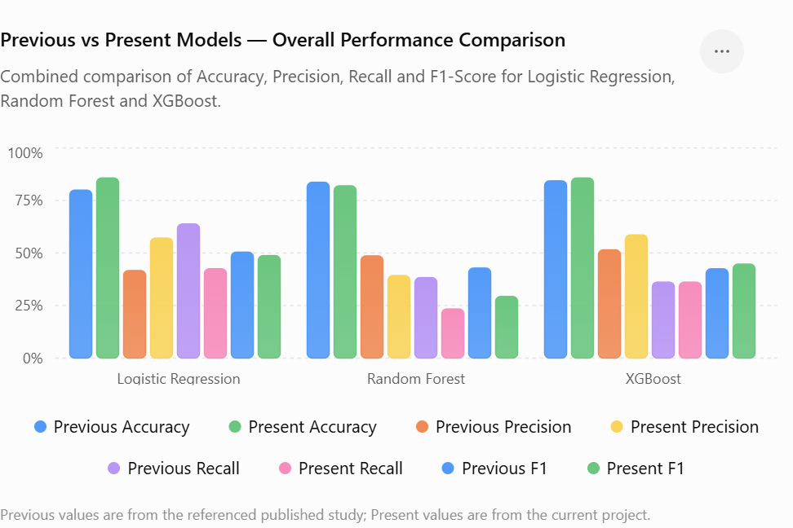

Key Comparative Observation
Previous approaches generally focus on predicting employee attrition using conventional machine-learning techniques. Our present framework extends this by comparing multiple models, handling class imbalance using SMOTE, and integrating SHAP and LIME to explain individual predictions.
In our experiments, XGBoost achieved the highest ROC-AUC (76.17%) and Precision (58.62%), while Logistic Regression achieved higher Recall and F1-Score. Therefore, XGBoost was selected for the final explainability system based on the ROC-AUC criterion.

